Year 3 Christianity - God
Year 3 Key Question (to be used all year): Who should we follow?
Focus Question (for this investigation): How (and why) have some people served God?
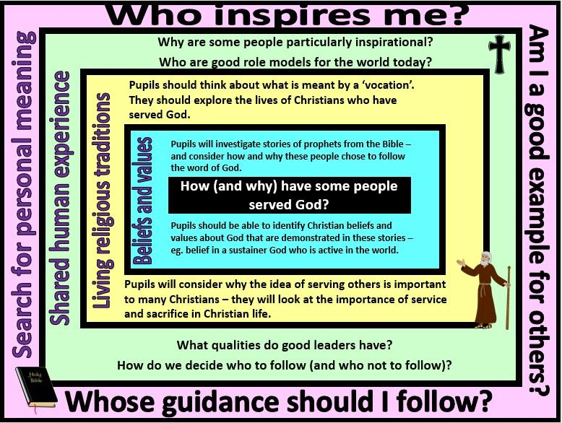

Focus Question: How (and why) have some people served God?
This unit enables pupils to explore Christian teachings and examples of people who have followed the word of God. They will investigate the prophets of the Old Testament and consider why these people chose to listen to God and how they put their beliefs into action. Pupils will also explore ways in which Christians today might follow God’s word and live a life of service – serving God and the community. They might look at inspiring Christians such as Dr Barnardo, Archbishop Desmond Tutu, William Booth and the work of the Salvation Army.
Children should have opportunities to discuss role models in their own lives and how/why some people have inspired them. They may also consider the idea that all people are inspired by others in some way – that the people they look up to will in turn look up to and follow someone who inspires and guides them.
They should be encouraged to make links with prior learning about the Christian concept of a God who has a special relationship with humanity; that God is described as creator and sustainer. One way that God is believed to sustain the world is through revealing his messages to the Prophets.
Field of Enquiry | Possible Teaching Ideas
Shared Human Experience  1 | - Look at examples of famous people – discuss which ones set a good example for others to follow and why  - Talk about the qualities that good leaders need. Discuss the value of being a leader, and of being a follower. Why do humans often want someone to follow?

Beliefs | - Read some of the stories of the Prophets from the Old Testament (eg. Noah, Abraham, Moses, Jonah) – there are a range of versions available that are suitable for children.  - Suggest what Christians might learn about God from these stories – eg. the belief that God cares about his created world and continues to act through people in order to intervene in human history.  - Discuss why God might choose to reveal himself in the way that he does in these stories. I.e. why might God speak through the burning bush in the story of Moses?  - Talk about how these people must have felt when they heard God – how did they respond initially, and why did they eventually decide to follow God’s word?
and
Values
2
Living | - Look at examples of Christians who have served God. Discuss what has inspired these people to live a life of service. To what extent are they good role models (are they good role models for everyone, or just for Christians)?  - Children could explore the work of the Salvation Army, whose mission statement includes ‘to serve suffering humanity’. KS2 resources for teaching about the Salvation Army can be found on their website https://www.salvationarmy.org.uk/religious-education#Primary Resources  - Invite in the leader of a local church to talk to the children about the Christian concept of having a vocation. Investigate how a church leader might serve the local church and community – make links with the idea of serving God.
Religious
Traditions
3
Search for | - Make a display for the classroom of people who inspire them  - P4C lesson on the concept of serving others – raise and discuss questions about the idea of being a servant: eg. Why is the term often seen in a negative way? Does serving others involve personal sacrifice? Why might some people want to live a life of service? Does it matter who or what we choose to serve?
Personal
Meaning
4

Y1 Learning - children will:
* know that the Abrahamic | * identify Christians who | * identify inspirational | * discuss who makes a good
faiths believe in prophets | might be described as people | people/role models for the | role model and why
(and that many of these are | who listened to and followed | world today | * raise and discuss questions
shared across the three | God | * describe the qualities that | about following others –
religions) | * describe how and why | inspirational people might | including both positive and
* identify Christian beliefs | some Christians might | have | negative responses
and values contained within | devote their lives to serving
stories of the prophets (eg. | God
Noah, Abraham, Moses, | * talk about what is meant
Jonah) | by a sense of vocation
* suggest why these
prophets chose to listen to
and follow God
Beliefs and values | Living religious traditions | Shared human experience | Search for personal meaning

