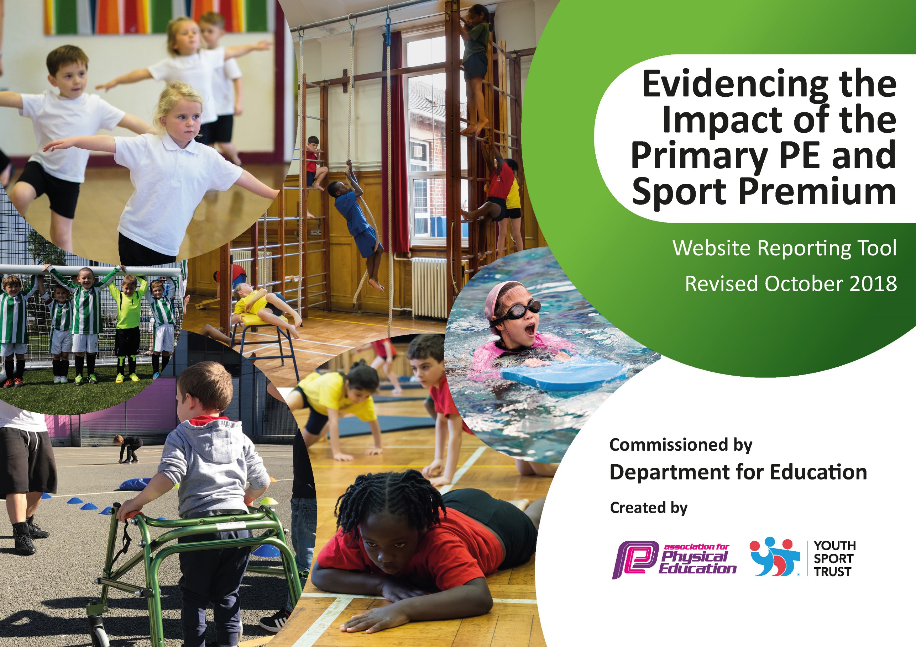
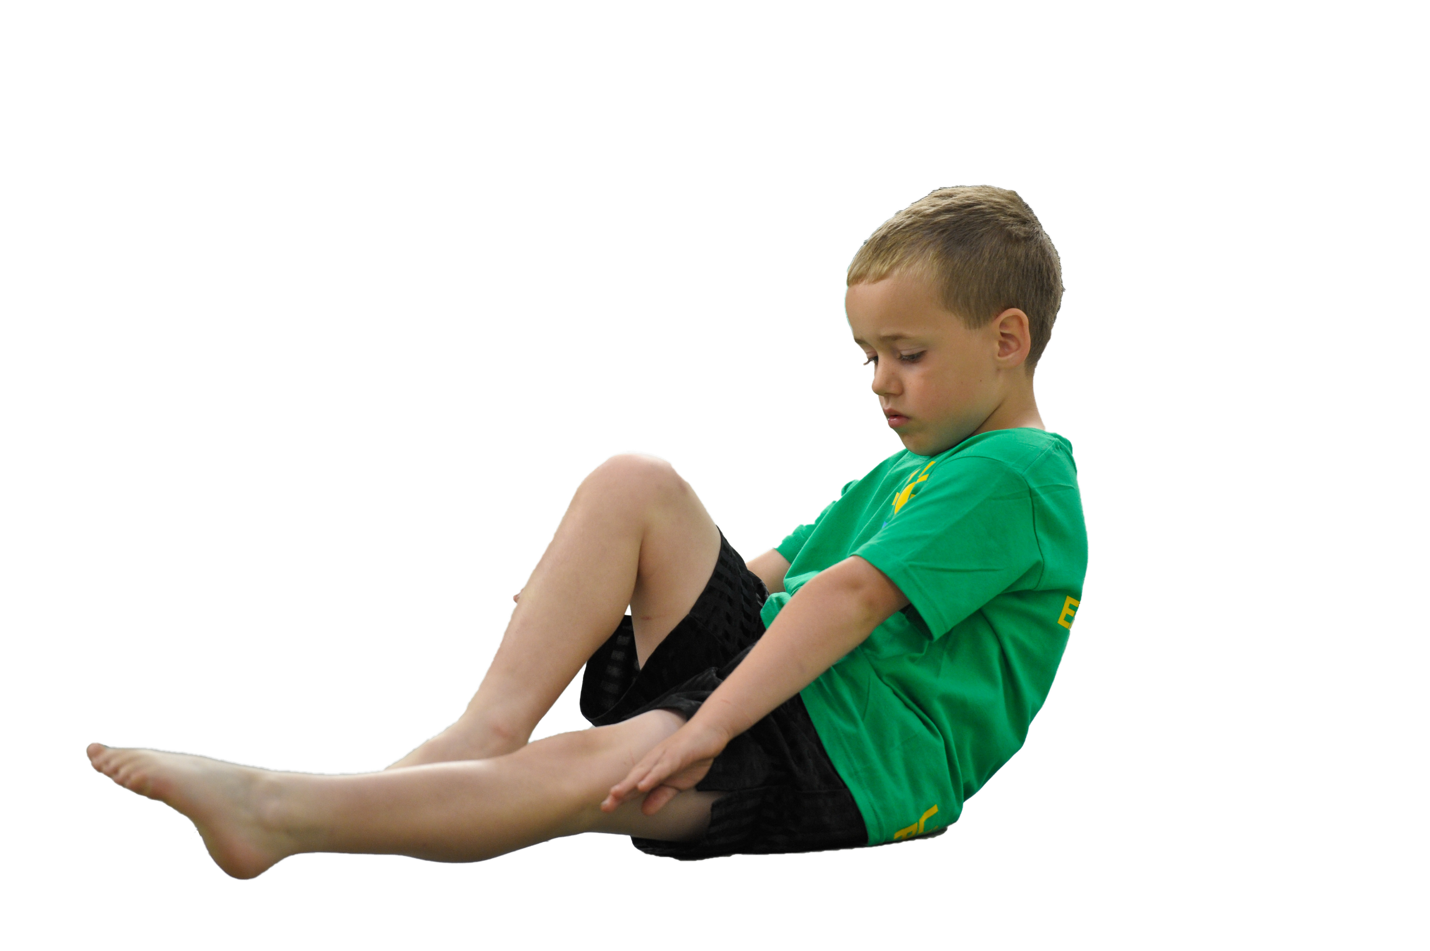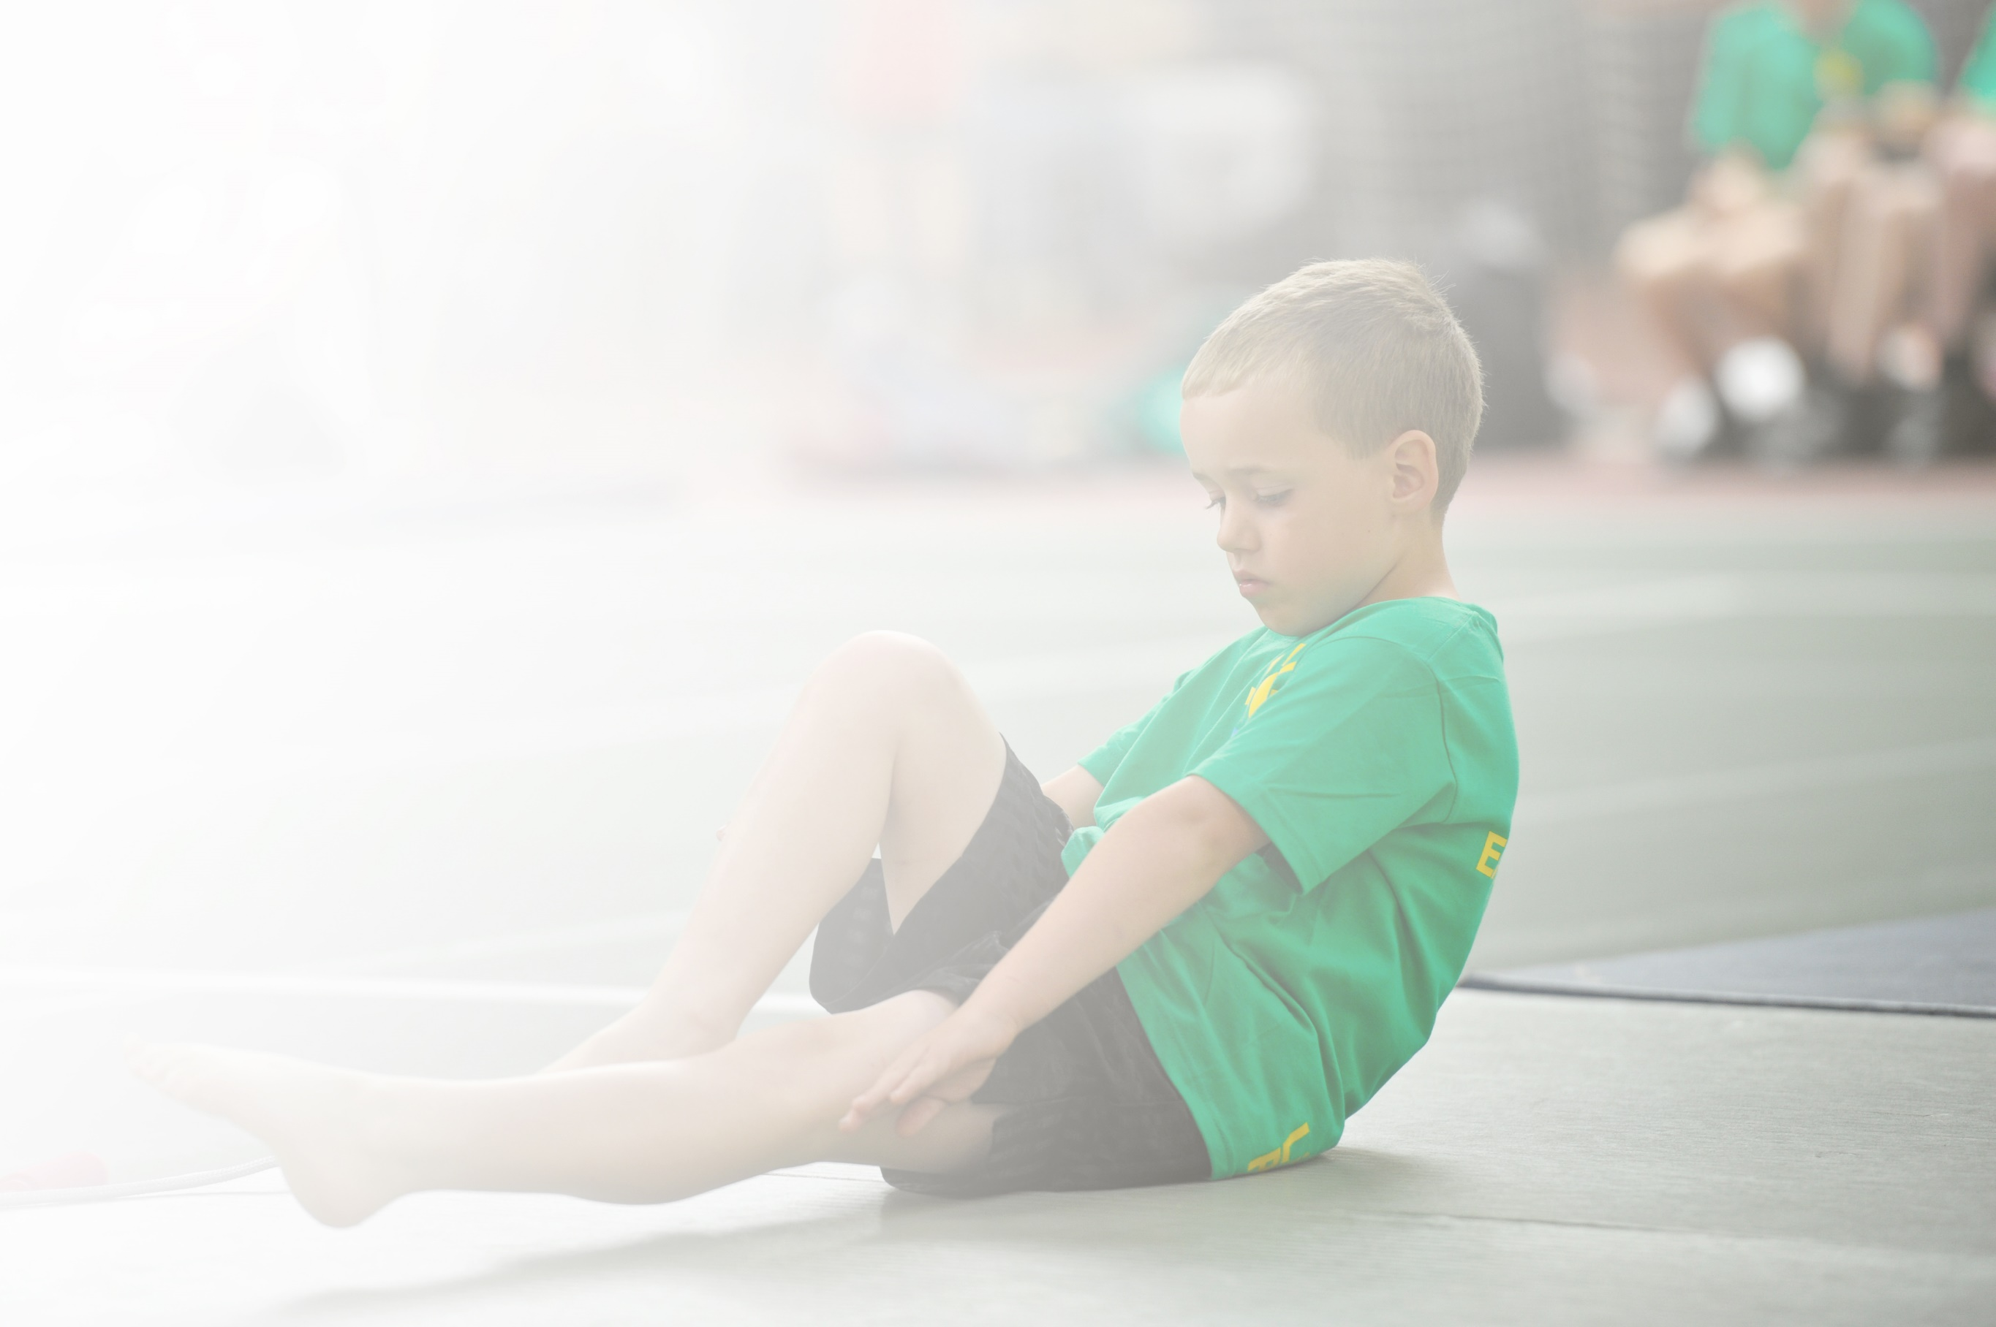Schools must use the funding to make additional and sustainable improvements to the quality of Physical Education, Sport and Physical Activity (PESPA) they offer. This means that you should use the Primary PE and Sport Premium to:

- Develop or add to the PESPA activities that your school already offer
- Build capacity and capability within the school to ensure that improvements made now will benefit pupils joining the school in future years

Please visit gov.uk for the revised DfE guidance including the 5 key indicators across which schools should demonstrate an improvement. This document will help you to review your provision and to report
your spend. DfE encourages schools to use this template as an effective way of meeting the reporting requirements of the Primary PE and Sport Premium.

We recommend you start by reflecting on the impact of current provision and reviewing the previous
spend. Under the Ofsted Schools Inspection Framework, inspectors will assess how effectively leaders use the Primary PE and Sport Premium and measure its impact on outcomes for pupils, and how effectively governors hold them to account for this.

Schools are required to publish details of how they spend this funding as well as on the impact it has on pupils’ PE and sport participation and attainment by the end of the summer term or by 31 July 2019 at the
latest.
We recommend regularly updating the table and publishing it
on your website throughout the year, as evidence of your
ongoing review into how you are using the money to
secure maximum, sustainable impact. To see an
example of how to complete the table please
click HERE.

Support for review and reflection - considering the 5 key indicators from DfE, what development needs are a priority for your setting and your students now and why? Use the space below to reflect on previous spend, identify current need and priorities for the future.

Key achievements to date: | Areas for further improvement and baseline evidence of need:
Swimming lessons for all classes from Y2 upwards to ensure that all children are able to meet the end of KS2 target of being able to swim at least 25m, and to provide children with water safety skills from a young age due to the number of canals and rivers in our local area.  An increase in children participating in extra-curricular activity and inter-school competitions as a result of the LAP (least active population) tracker used across school.  Specialist coaching in a range of sports including cricket, ice-skating, judo and karate. | Increase use of PE passport across school to ensure full coverage and regular assessment to identify gaps in learning following Covid-29 school closures.  Review School Measurement Programme data when measurements resume in 2021 to identify whether there has been any increase in the proportion of children who are overweight/obese following school closures, and identify ways to improve health and fitness across school.  Review PE long term planning to reflect the school context and pupil needs (highest % of SEN children across the LA – 50 schools)

Year 6 children usually attend swimming lessons in the Summer term – due to school closures (Covid-19) in 2020, this did not happen. Percentages are given based on the Y6 cohort’s performance in swimming lessons in Y5.

Meeting national curriculum requirements for swimming and water safety | Please complete all of the below:
What percentage of your current Year 6 cohort swim competently, confidently and proficiently over a distance of at least 25 metres?  N.B. Even though your children may swim in another year please report on their attainment on leaving  primary school. | 74%
What percentage of your current Year 6 cohort use a range of strokes effectively [for example, front crawl, backstroke and breaststroke]? | 69%
What percentage of your current Year 6 cohort perform safe self-rescue in different water-based situations? | 88%
Schools can choose to use the Primary PE and Sport Premium to provide additional provision for swimming but this must be for activity over and above the national curriculum requirements. Have you used it in this way? | No

Action Plan and Budget Tracking
Capture your intended annual spend against the 5 key indicators. Clarify the success criteria and evidence of impact that you intend to measure to evaluate for students today and for the future.

Academic Year: 2019/20 | Total fund allocated: £17590 | Date Updated: July 2020
Key indicator 1: The engagement of all pupils in regular physical activity – Chief Medical Officer guidelines recommend that primary school children undertake at least 30 minutes of physical activity a day in school |  |  |  | Percentage of total allocation:
 |  |  |  | 6%
School focus with clarity on intended impact on pupils: | Actions to achieve: | Funding allocated: | Evidence and impact: | Sustainability and suggested next steps:
Opportunities in place to ensure all pupils receive 30 minutes of physical activity each day in school.  To promote healthy eating and active lifestyle as part of our school ethos  To ensure there are opportunities for active learning across core and foundation subjects | Use of daily mile before playtime  Extend provision on playground – extend the trim trail.  Healthy Eating mission tracker/Fit4life sessions with children  Maths of the Day delivered by teachers  English of the Day to be delivered by teachers | MOTD £545  EOTD £545 | Pupil Voice  Monitoring by PE coordinator – on playground and during lessons  Lunchtime Rota of activities  Afterschool Club registers  Active Planner – Heat tracker | Review LTP to incorporate health and fitness activities at KS2.
Key indicator 2: The profile of PESSPA being raised across the school as a tool for whole school improvement |  |  |  | Percentage of total allocation:
 |  |  |  | 41%
School focus with clarity on intended impact on pupils: | Actions to achieve: | Funding allocated: | Evidence and impact: | Sustainability and suggested next steps:
Maintain a raised profile of PE/School Sport with staff, all pupils and parents within school and local community.  Participate in School Games Mark to encourage children to participate in competition, including digital competition  Develop children’s confidence, self-esteem, communication to allow them to take part in collaborate sporting activity | Use of Sports Captains to promote events and competitions through school and on the website; including adding to the school blog.  School Games Organising Crew to be represented by children throughout school to help to design PE provision, monitor participation, lead in games and activities. | £6713 - One Goal mentoring  Halton School Games fee £495 | Monitoring by PE coordinator  Pupil Voice | Due to Covid-19 closures in the summer term, there were not as many inter-school competitions as school would normally participate in.  Increase intra school competitions until reduction in covid restrictions, to ensure children are still able to participate in competitions and do not lose confidence developed via mentoring.

Key indicator 3: Increased confidence, knowledge and skills of all staff in teaching PE and sport |  |  |  | Percentage of total allocation:
 |  |  |  | 32%
School focus with clarity on intended  impact on pupils: | Actions to achieve: | Funding  allocated: | Evidence and impact: | Sustainability and suggested  next steps:
Deliver CPD staff to improve staff confidence  Equip staff with a range of teaching strategies and lessons ideas that promote leadership, communication and collaboration from children | Staff to continue CPD through Progressive Sports training  OneGoal Team-teaching  PE Passport app | £5,600  £150 | Staff feedback, monitoring by subject leader.  Staff, particularly those new to teaching, developed confidence and skills in teaching a range of sports through participation in collaborative teaching. | Further use of PE passport as an assessment tool.
Key indicator 4: Broader experience of a range of sports and activities offered to all pupils |  |  |  | Percentage of total allocation:
 |  |  |  | 11%
School focus with clarity on intended  impact on pupils: | Actions to achieve: | Funding  allocated: | Evidence and impact: | Sustainability and suggested  next steps:
Additional achievements:  Engage at least 50% of pupils in extracurricular sporting and physical activity every week  Over the course of the academic year, have targeted provision for those least active young people in your school and a minimum take up of at least 15% from those identified as least active at the start of the academic year.  use competitions as an incentive to recruit LAP for afterschool clubs | Provide a wide range of sporting and physical activity through intra-school/inter-school competitions, clubs, events and lessons within school.  Engage least activity population and provide a range of activities to engage all groups within school, inc. girls and SEND | £1865 | Lunctime extra-curricular clubs for those children who cannot attend after school (SEN transport) increased the proportion of SEN and disadvantaged children accessing sport outside of their PE lessons.  Y3, 4, 5 & 6 participated in One Goal Reslience Day workshops – this improved attitudes to team work and motivation in physical activity.  Use of LAP tracker enabled staff to choose a variety of children for sporting teams and clubs – although this was limited to Autumn term and Spring 1 due to school closures. | Review of LTP to reflect school context and children’s needs – greater range of inclusive sports at KS2.  Focus on fundamentals in KS1 to address gaps from missed learning during school closures.
Key indicator 5: Increased participation in competitive sport |  |  |  | Percentage of total allocation:
 |  |  |  | 17%
School focus with clarity on intended  impact on pupils: | Actions to achieve: | Funding  allocated: | Evidence and impact: | Sustainability and suggested  next steps:
Children to take part in a range of intra-school and inter-school competitions  Children to be encouraged to take part in a number of clubs, events and competitions  Make an intraschool competition calendar to encourage more participation in competitions within school | Staff to set up intra-school competitions in different contexts e.g. individual/group competitions, mixed classes, mixed key stage, teacher v pupil  To participate in a range of inter-school competitions | £450 – Halton Competition Calendar  £280 – FUTSAL  £250 – cricket  £1440 - karate  £500 - transport | Club attendance register  Competition attendance  Pupil voice  Some competitions and coaching did not go ahead due to school closures. | Review competition opportunities – intra and inter with a focus on those missed during Spring/Summer 2020 as an identified priority.

