**SEN policy**

**The Brow CP School**

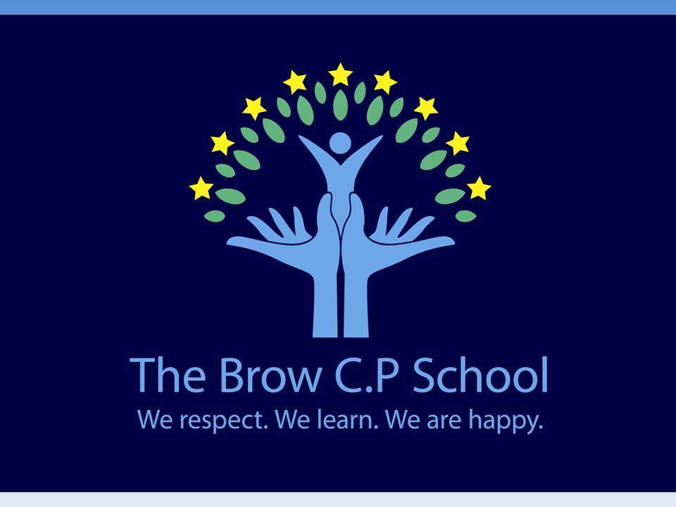

| **Approved by:** | Lindey Webb | **Date:** July 2023 |
| --- | --- | --- |
| **Last reviewed on:** | July 2022 | |
| **Next review due by:** | September 2024 | |

**Contents**

1. Aims 3

2. Legislation and guidance 3

3. Definitions 3

4. Roles and responsibilities 4

5. SEN information report overview 5

6. Monitoring arrangements 8

7. Links with other policies and documents 8

**…………………………………………………………………………………………………………………………….**

# 1. Aims

Our SEN policy and information report aims to:

* All children, including those with SEN or disability secure good outcomes academically, socially and personally
* Everyone achieves their full potential
* Teaching and learning is personalised, creative, challenging and fun
* Children are inspired and supported to develop interests and skills both in and outside school
* Positive links with the local community create strong partnerships
* A sense of mutual respect, care and responsibility is shown for everyone and everything in school
* Children can contribute positively to a changing society
* Everyone in school feels safe, supported, valued and happy
* Children are supported to make informed decisions for a healthy lifestyle- physically, emotionally, socially and academically
* We are leaders in best educational practice

# 2. Legislation and guidance :

This policy and information report is based on the statutory [Special Educational Needs and Disability (SEND) Code of Practice](https://www.gov.uk/government/uploads/system/uploads/attachment_data/file/398815/SEND_Code_of_Practice_January_2015.pdf) and the following legislation:

* [Part 3 of the Children and Families Act 2014](http://www.legislation.gov.uk/ukpga/2014/6/part/3), which sets out schools’ responsibilities for pupils with SEN and disabilities
* [The Special Educational Needs and Disability Regulations 2014](http://www.legislation.gov.uk/uksi/2014/1530/contents/made), which set out schools’ responsibilities for education, health and care (EHC) plans, SEN co-ordinators (SENCOs) and the SEN information report

# 3. Definitions

A pupil has SEN if they have a learning difficulty or disability which calls for special educational provision to be made for them.

They have a learning difficulty or disability if they have:

* A significantly greater difficulty in learning than the majority of others of the same age, or
* A disability which prevents or hinders them from making use of facilities of a kind generally provided for others of the same age in mainstream schools

Special educational provision is educational or training provision that is additional to, or different from, that made generally for other children or young people of the same age by mainstream schools.

# 4. Roles and responsibilities

**4.1 The SENCO**

The SENCO is Jill Jones

They will:

* Work with the headteacher and SEN governor to determine the strategic development of the SEN policy and provision in the school
* Have day-to-day responsibility for the operation of this SEN policy and the co-ordination of specific provision made to support individual pupils with SEN, including those who have EHC plans
* Provide professional guidance to colleagues and work with staff, parents, and other agencies to ensure that pupils with SEN receive appropriate support and high quality teaching
* Advise on the graduated approach to providing SEN support
* Advise on the deployment of the school’s delegated budget and other resources to meet pupils’ needs effectively
* Be the point of contact for external agencies, especially the local authority and its support services
* Liaise with potential next providers of education to ensure pupils and their parents are informed about options and a smooth transition is planned
* Work with the headteacher and governing board to ensure that the school meets its responsibilities under the Equality Act 2010 with regard to reasonable adjustments and access arrangements
* Ensure the school keeps the records of all pupils with SEN up to date

**4.2 The SEN governor**

The SEN governor is: Karen Forster

The SEN governor will:

* Help to raise awareness of SEN issues at governing board meetings
* Monitor the quality and effectiveness of SEN and disability provision within the school and update the governing board on this
* Work with the headteacher and SENCO to determine the strategic development of the SEN policy and provision in the school

**4.3 The headteacher**

The headteacher will:

* Work with the SENCO and SEN governor to determine the strategic development of the SEN policy and provision in the school
* Have overall responsibility for the provision and progress of learners with SEN and/or a disability

**4.4 Class teachers**

Each class teacher is responsible for:

* The progress and development of every pupil in their class
* Working closely with any teaching assistants or specialist staff to plan and assess the impact of support and interventions and how they can be linked to classroom teaching
* Working with the SENCO to review each pupil’s progress and development and decide on any changes to provision
* Ensuring they follow this SEN policy

# 5. SEN information report overview

**5.1 The kinds of SEN that are provided for**

Our school currently provides additional and/or different provision for a range of needs, including:

* Communication and interaction, for example, autistic spectrum disorder, Asperger’s Syndrome, speech and language difficulties
* Cognition and learning, for example, dyslexia, dyspraxia, phonological difficulties
* Social, emotional and mental health difficulties, for example, attention deficit hyperactivity disorder (ADHD), anxiety
* Sensory and/or physical needs, for example, visual impairments, hearing impairments, processing difficulties, epilepsy
* Moderate/severe/profound and multiple learning difficulties

**5.2 Identifying pupils with SEN and assessing their needs**

We will assess each pupil’s current skills and levels of attainment on entry, which will build on previous settings and Key Stages, where appropriate. Class teachers will make regular assessments of progress for all pupils and identify those whose progress:

* Is significantly slower than that of their peers starting from the same baseline
* Fails to match or better the child’s previous rate of progress
* Fails to close the attainment gap between the child and their peers
* Widens the attainment gap

This may include progress in areas other than attainment, for example, social needs.

Slow progress and low attainment will not automatically mean a pupil is recorded as having SEN.

When deciding whether special educational provision is required, we will start with the desired outcomes, including the expected progress and attainment, and the views and the wishes of the pupil and their parents. We will use this to determine the support that is needed and whether we can provide it by adapting our core offer, or whether something different or additional is needed.

**5.3 Consulting and involving pupils and parents**

We will have an early discussion with the pupil and their parents when identifying whether they need special educational provision. These conversations will make sure that:

* Everyone develops a good understanding of the pupil’s areas of strength and difficulty
* We take into account the parents’ concerns
* Everyone understands the agreed outcomes sought for the child
* Everyone is clear on what the next steps are

Notes of these early discussions will be added to the pupil’s record and given to their parents.

We will formally notify parents when it is decided that a pupil will receive SEN support.

**5.4 Assessing and reviewing pupils' progress towards outcomes**

We will follow the graduated approach and the four-part cycle of **assess, plan, do, review**.

The class will work with the SENCO to carry out a clear analysis of the pupil’s needs. This will draw on:

* The teacher’s assessment and experience of the pupil
* Their previous progress and attainment and behaviour
* The individual’s development in comparison to their peers and national data
* The views and experience of parents
* The pupil’s own views
* Advice from external support services, if relevant

The assessment will be reviewed regularly.

All teachers and support staff who work with the pupil will be made aware of their needs, the outcomes sought, the support provided, and any teaching strategies or approaches that are required. We will regularly review the effectiveness of the support and interventions and their impact on the pupil’s progress.

**5.5 Supporting pupils moving between phases and preparing for adulthood**

We will share information with the school, college, or other setting the pupil is moving to. We will agree with parents and pupils which information will be shared as part of this.

We consider the importance of transition in children’s lives throughout their time at The Brow. All transitions are carefully planned and each is considered around the needs of the child. A transition plan is developed to support the child during all changes.

**5.6 Our approach to teaching pupils with SEN**

Teachers are responsible and accountable for the progress and development of all the pupils in their class.

High quality teaching is our first step in responding to pupils who have SEN. This will be differentiated for individual pupils.

We will also provide the following interventions:

1. **Communication and interaction**

Provision: We have received whole school training from the Together Trust to support all children’s communication skills.

All children in nursery and reception are assessed on entry using the Early Years Foundation Stage Curriculum. Appropriate interventions are the then planned in as part of whole class teaching and for individual and small group support. In addition to this we provide small group Talk Time to help develop social skills and support children to develop their communication skills with their peers.

The use of visual supports are used as a communication tool to support children understand what is asked of them and to help children communicate with their peers and other adults.

Children who have been assessed by speech and language therapy service have a care plan will receive regular, designated time with a teaching assistant to work on targets from their care plan.

In key stage 1 we offer a range of speech and language interventions delivered by a highly skilled teaching assistant who has worked closely with the speech therapy service. For individual children, we may provide visual supports to aid their communication and understanding skills, for example, access to a visual timetable and communication fans.

In key stage 2 we offer a range of interventions delivered by a highly skilled teaching assistant. Interventions develop speech sounds, work on sequencing and understanding vocabulary.

Children with Autism Spectrum Disorder or social communication difficulties may receive a tailored curriculum delivered in class.

**Cognition and learning**

Provision: School operates a whole school approach to developing early reading skills following letters and sounds and no nonsense phonics. The Brow also offers a range of intervention programmes aimed at narrowing the gaps with their peers. These interventions are bespoke to the individual needs of the child and are reviewed regularly with parents. We use computer based programmes to support reading and spelling skills bespoke 1:1 and small group work that is rooted in specialist teaching and our phonics scheme.

In mathematics, the school follows a structured and cumulative teaching approach to developing mathematical skills. We use White Rose Maths as our maths scheme and use pre and post lesson interventions alongside structured interventions to promote and develop basic mathematical skills.

Deployment of advice and strategies by any specialists who may have seen or assessed a child with a cognition and learning need. The school may also apply for a block of specialist teaching for children with SEN from the SEN Service within the Local Authority.

1. **Social, emotional and mental health**

The school has a clear behaviour policy and strategy of rewards and sanctions which sets out expectations for positive behaviour management. In addition to this, we use ABC behaviour forms to help track triggers for children who may have a social, emotional or mental health need.

We have undergone a range of whole staff training focusing on supporting children’s well being and helping them to manage anxiety. We use emotion coaching to help children manage their feelings and actions.

We have two members of staff who are trained ELSA and provide support and interventions for children with social, emotional and mental health needs.

The school will also seek the advice and recommendations from the Attendance and Behaviour Service and Positive Behaviour Support Team to provide further individual advice and support. The school will also refer a child to CAMHS if it is necessary to meet the needs of a child with social, emotional and mental health needs.

1. **Sensory and/or physical needs**

The school follows the advice and recommendations from external agencies and ensures that strategies are acted upon by any adult working with the child. The Brow aims to refer a child early to Woodview CDC if there are any concerns about their sensory needs or physical development. We also seek specialist advice from the specialist teachers from within the local authority to ensure that necessary adaptations have been made. The school is experienced in following sensory diets provided by Occupational Therapy Service and any care plan activities provided.

We also use checklists to measure the impact of sensory distractions for children who may struggle in this area. Steps could be put in place to minimise sensory distractions and ensure that a child is not overloaded. It also provides an opportunity to measure the impact of any intervention we put in place.

**5.7 Adaptations to the curriculum and learning environment**

We make the following adaptations to ensure all pupils’ needs are met:

* Differentiating our curriculum to ensure all pupils are able to access it, for example, by grouping, 1:1 work, teaching style, content of the lesson, etc.
* Adapting our resources and staffing
* Using recommended aids, such as laptops, coloured overlays, visual timetables, larger font, etc.
* Differentiating our teaching, for example, giving longer processing times, pre-teaching of key vocabulary, reading instructions aloud, etc.

**5.8 Additional support for learning**

We have teams of teaching assistants who are trained to deliver interventions such as multi sensory phonics and maths sessions, SEHM interventions, Wellcomm interventions.

Pupils are highlighted for intervention through progress meetings and discussions with the SENCO. Following progress meetings a provision map is set up for each class detailing interventions and duration.

TAs assigned to the class are responsible for delivering interventions.

5.9 Expertise and training of staff

Our SENCO has 10 experience in this role and has worked as an advisory teacher with the local authority.

They are allocated 10 a week to manage SEN provision.

We have a team of teaching assistants, resource base teacher and SENCO who are trained to deliver SEN provision.

In the last academic year, staff have been trained in THRASS, attention autism, Pivotal behavoiur strategies, Cuisenaire rods to support maths.

We use specialist staff for Wellcomm and bespoke multi sensory interventions.

**5.10 Securing equipment and facilities**

We work with all agencies and the local authority to ensure we use appropriate equipment and have facilities to support pupils e.g. when purchasing specialist chairs, sensory equipment, developments to the site.

**5.11 Evaluating the effectiveness of SEN provision**

We evaluate the effectiveness of provision for pupils with SEN by:

* Reviewing pupils’ individual progress towards their goals each term
* Reviewing the impact of interventions after 6 weeks.
* Using pupil questionnaires
* Monitoring by the SENCO
* Using provision maps to measure progress
* Holding annual reviews for pupils with statements of SEN or EHC plans

**5.12 Enabling pupils with SEN to engage in activities available to those in the school who do not have SEN**

All of our extra-curricular activities and school visits are available to all our pupils, including our before-and after-school clubs.

All pupils are encouraged to go on our residential trip(s).

All pupils are encouraged to take part in sports day/school plays/special workshops, etc.

No pupil is ever excluded from taking part in these activities because of their SEN or disability.

* *We follow the local authority’s admissions procedures for all pupils. When required children can have a phased transition to our school to help them settle and feel comfortable.*
* *We have carefully considered and analysed the impact of this policy on equality and the possible implications for pupils with protected characteristics, as part of our commitment to meet the Public Sector Equality Duty (PSED) requirement to have due regard to the need to eliminate discrimination, advance equality of opportunity and foster good relations.*
* *Our accessibility plan can be obtained on request.*

**5.13 Support for improving emotional and social development**

We provide support for pupils to improve their emotional and social development in the following ways:

* Pupils with SEN are encouraged to be part of the school council
* All pupils have access to weekly Forest School sessions focusing on team work, resilience, building self esteem and promoting independence.
* We have a termly focus on developing positive behaviour and attitudes for staff and all children.
* Our work closely matches that of Paul Dix and Pivotal Education.
* We have a zero tolerance approach to bullying.

**5.14 Working with other agencies**

A full list of our external partners who we work with can be found in our contribution to the Local Offer. Extending our school approach, we commission using an outcomes-based approach. This enables us to hold our partners and ourselves to account.

The Brow works closely with outside agencies and the Local Authority to ensure a coordinated approach in supporting children at the school. We aim to refer a child to services early.

We work closely with health and education services including: Education and Child Psychology Service, Local Authority Specialist Teachers, Speech and Language Therapy Service, Woodview Child Development Centre, Paediatrics, Occupation and Physiotherapy Service, Attendance and Behaviour Service, Positive Behaviour Service, ICART and Social Care to ensure a coordinated and multi-agency approach to supporting children with SEN and additional needs.

**5.15 Complaints about SEN provision**

Complaints about SEN provision in our school should be made to the class teacher in the first instance. They will then be referred to the school’s complaints policy.

The parents of pupils with disabilities have the right to make disability discrimination claims to the first-tier SEND tribunal if they believe that our school has discriminated against their children. They can make a claim about alleged discrimination regarding:

* Exclusions
* Provision of education and associated services
* Making reasonable adjustments, including the provision of auxiliary aids and services

**5.16 Contact details of support services for parents of pupils with SEN**

Please refer to Halton’s Local Offer**:** [**http://localoffer.haltonchildrenstrust.co.uk/**](http://localoffer.haltonchildrenstrust.co.uk/)

**5.17 Contact details for raising concerns**

**Class teacher in the first instance and then Mrs Jill Jones SENCO 01928 563089**

**5.18 The local authority local offer**

Our contribution to the local off can be found on the local offer website (see above)

# 6. Monitoring arrangements

This policy and information report will be reviewed by the Governing Board **every year**. It will also be updated if any changes to the information are made during the year.

It will be approved by the governing board.

# 7. Links with other policies and documents

This policy links to our policies on:

* Accessibility plan
* Behaviour
* Equality information and objectives
* Supporting pupils with medical conditions