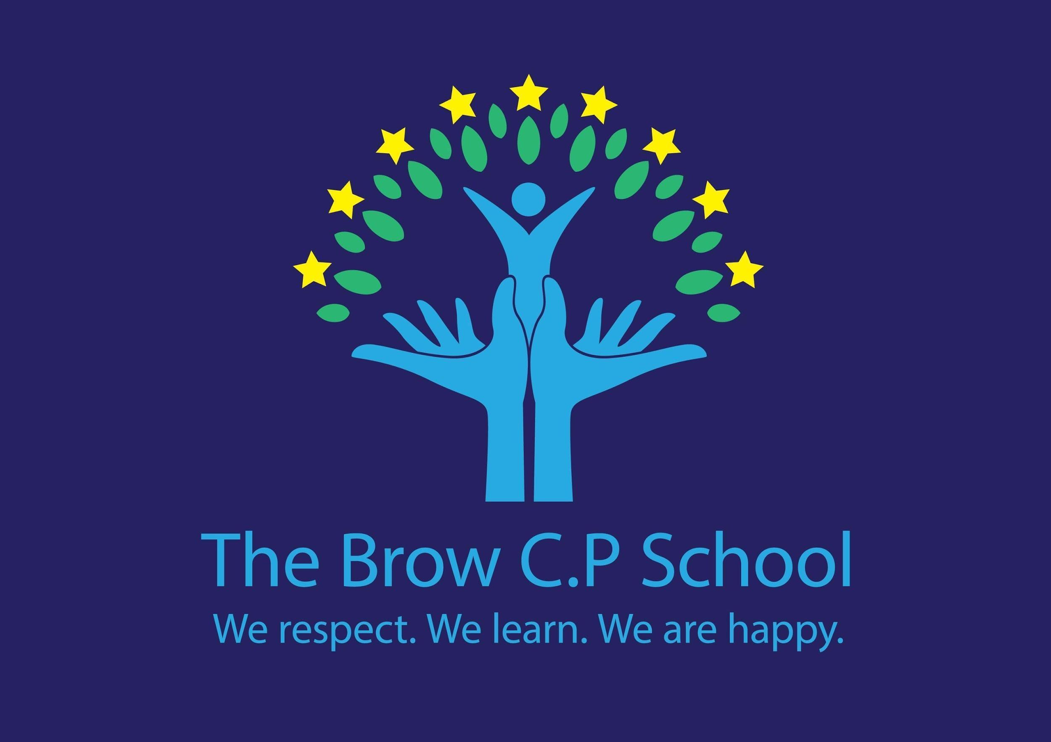
SEN Information Report
September 2023

Special Needs Coordinator: Mrs Jill Jones
SEN Governor: Mrs Karen Forster
Contact: 01928 563089
Dedicated SEN time: 1 full day per week

Local Offer Contribution: http://thebrowprimaryschool.com/halton/primary/thebrow/site/pages/aboutus/localoffer
The Brow CP School is an inclusive, mainstream primary school offering places for children between the ages of 3 and 11. The school has a key stage 1 and key stage 2 resource base providing support for children with Speech, language and communication needs and associated behaviours.
Our Motto
We respect. We learn. We are happy.
Whole School Approach:
High quality first teaching underpins everything that we do at The Brow. We review our provision on annual basis and respond to the needs of every child at our school. Every member of staff has high expectations for all children. Quality first teaching and the application of a differentiated and personalised approach to teaching and learning underpins our curriculum. We are working hard to become a nurturing school to ensure the well being of all our children. We make it a point to discuss aspirations with ALL our learners. All teachers are responsible for every child in their care, including those with special educational needs.

How do we identify special educational needs?
At The Brow we believe in early identification of special educational needs. Every child’s attainment will be assessed on entry to school so that the foundations during the child’s pre-school years can be built on. If a child has already been identified as having a special educational need in their early years setting, then the class teacher and SENCO will use this information to inform planning and support (See SEN Policy, 2023/2024)
Children may be identified by the following:

- A child who is working below age related expectations despite receiving quality first teaching and appropriate rigorous intervention
- Concerns raised by a teacher and shared with the SENCO
- Consultation between class teachers and the leadership team during pupil progress meeting
- Following an assessment completed by a specialist outside agency for example, Education and Child Psychology Service
- Parental requests for further assessment and investigation which leads to class teachers and the SENCO identifying a SEN.

What happens if a parent is concerned about their child’s learning?

The Brow supports and encourages parents and carers to share their concerns about their child’s development. Partnership plays a crucial role in enabling children with SEN to achieve their full potential. Parents and carers hold key information and have the knowledge and experience to contribute to the shared view of their child’s needs. All parents and carers of children with SEN will be treated as equal partners and given support to play an active role in their child’s education.
Who can I contact if I am concerned about my child’s learning?
If a parent or carer has concerns then they should be logged with the child’s class teacher in the first instance. If the difficulty persists then the class teacher will share this with the SENCO who may complete some further assessment and investigation of the child to see if there are any special educational needs which have not been assessed.
What is the criterion for SEN Support?
- A child makes little or no progress, even when teaching approaches are targeted at a child’s identified area of weakness;
- Shows signs of difficulty in developing literacy or mathematics skills which result in poor attainment in some curriculum areas;
- Presents persistent social, emotional or mental health difficulties which have not been improved as a result of deploying the behaviour strategy and positive reward systems within the school;
- Has sensory or physical needs and continues to make little or no progress despite specialist resources;
- Has communication and/ or interaction difficulties and continues to make little or no progress academically and socially.
Parents and carers are expected to contribute to the assessment and decision to place a child on the SEN register.
Underpinning ALL our provision in school is the graduated approach cycle of:
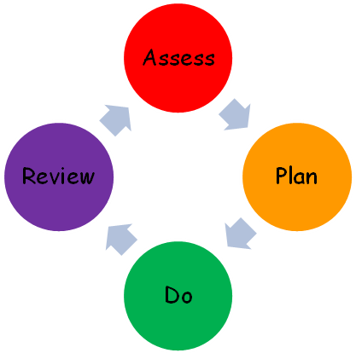

Assess:
This initial assessment described above will inform any SEN plan and will be updated on a regular basis. Teachers are expected to report on pupil progress on a half termly basis. In addition to this, children with SEN may receive additional assessments around their area of need formally three a year and informally during intervention sessions on a more regular basis. Some children require additional assessment and we use the Birmingham SEN toolkit to provide this.
Plan:
When a child is placed on the SEN register, an SEN support plan which details adjustments to teaching and learning, what is additional to or different from that usually provided for children at our school. This plan will also provide short term outcomes that we expect the child to achieve as a result of the provision. This plan will be person centred and it is our expectation that it will be written by the class teacher together with parents and carers and the child. The SENCO may also be involved in this process. In addition to this, teacher planning will also detail adjustments to teaching and learning that is tailored and differentiated to meet the needs of every pupil.
Do:
Class teachers maintain responsibility for every child in their class. Class teachers have high expectations for every child including those with SEN. As part of their SEN provision it may be that a child needs to receive additional support or intervention which is not normally afforded to all children. In this instance, details of any intervention or specialist provision provided outside of the main classroom teaching will be provided to the class teacher and opportunities made for specialist teachers and teaching assistants to share this information with the class teacher. It is the expectation that the same or similar strategies are deployed in their mainstream class teaching so that techniques become familiar for children. Any teacher or teaching assistant working with a child on SEN support will be aware of advice and strategies provided by professionals so that they can be deployed consistently.
Review:
SEN Support Plans will be updated on a termly basis. Children, parents and carers, class teachers, SENCO and any support staff working with the child will be expected to contribute to this. The review will detail the progress that the child has made in securing good outcomes and any changes or adjustments to provision that needs to be made. At this review meeting, new outcomes will be devised for the child. The child’s continued placement as SEN Support will also be discussed and whether they continue to require the additional and different provision.
Having consulted with children, young people and their parents, all our additional provision (internal or external) is based on an agreed outcomes approach.
SEN Needs:
What sort of provision will my child receive?
Children and young people’s SEN are generally thought of in the following four broad areas of need and support:
- Communication and interaction
Provision: We have received whole school training from the Together Trust to support all children’s communication skills.
All children in nursery and reception are assessed on entry using the Early Years Foundation Stage Curriculum. Appropriate interventions are the then planned in as part of whole class teaching and for individual and small group support. In addition to this we provide small group Talk Time to help develop social skills and support children to develop their communication skills with their peers.
The use of visual supports are used as a communication tool to support children understand what is asked of them and to help children communicate with their peers and other adults.
Children who have been assessed by speech and language therapy service have a care plan will receive regular, designated time with a teaching assistant to work on targets from their care plan.
In key stage 1 we offer a range of speech and language interventions delivered by a highly skilled teaching assistant who has worked closely with the speech therapy service. For individual children, we may provide visual supports to aid their communication and understanding skills, for example, access to a visual timetable and communication fans.
In key stage 2 we offer a range of interventions delivered by a highly skilled teaching assistant. Interventions develop speech sounds, work on sequencing and understanding vocabulary.
Children with Autism Spectrum Disorder or social communication difficulties may receive a tailored curriculum delivered in class.
Cognition and learning
Provision: School operates a whole school approach to developing early reading skills following letters and sounds and no nonsense phonics. The Brow also offers a range of intervention programmes aimed at narrowing the gaps with their peers. These interventions are bespoke to the individual needs of the child and are reviewed regularly with parents. We use computer based programmes to support reading and spelling skills bespoke 1:1 and small group work that is rooted in specialist teaching and our phonics scheme.
In mathematics, the school follows a structured and cumulative teaching approach to developing mathematical skills. We use White Rose Maths as our maths scheme and use pre and post lesson interventions alongside structured interventions to promote and develop basic mathematical skills.
Deployment of advice and strategies by any specialists who may have seen or assessed a child with a cognition and learning need. The school may also apply for a block of specialist teaching for children with SEN from the SEN Service within the Local Authority.
- Social, emotional and mental health
The school has a clear behaviour policy and strategy of rewards and sanctions which sets out expectations for positive behaviour management. In addition to this, we use ABC behaviour forms to help track triggers for children who may have a social, emotional or mental health need.
We have undergone a range of whole staff training focusing on supporting children’s well being and helping them to manage anxiety. We are in the process of developing as a nurturing school. We use emotion coaching to help children manage their feelings and actions.
We offer a range of personalised interventions to support children with social and emotional aspects of learning.
We have a well established family support worker, Mrs Geraghty to work with children individually to help them develop social and emotional skills. We currently have two members of staff who have undertaken the ELSA training and they deliver interventions to individual children and groups of children focusing on the specific area of need.
The school will also seek the advice and recommendations from the Attendance and Behaviour Service and Positive Behaviour Support Team to provide further individual advice and support. The school will also refer a child to CAMHS if it is necessary to meet the needs of a child with social, emotional and mental health needs.
- Sensory and/or physical needs
The school follows the advice and recommendations from external agencies and ensures that strategies are acted upon by any adult working with the child. The Brow aims to refer a child early to Woodview CDC if there are any concerns about their sensory needs or physical development. We also seek specialist advice from the specialist teachers from within the local authority to ensure that necessary adaptations have been made. The school is experienced in following sensory diets provided by Occupational Therapy Service and any care plan activities provided.
We also use checklists to measure the impact of sensory distractions for children who may struggle in this area. Steps could be put in place to minimise sensory distractions and ensure that a child is not overloaded. It also provides an opportunity to measure the impact of any intervention we put in place.
(Reference: Accessibility Plan and SEN Policy)
How many children are currently accessing SEN provision in the school?
As of September 2023, over 60% of our children have a special educational need, 40% of those children are identified as having SEN Support and 20% of the children have an EHCP.
We have 14 children accessing the Key Stage 2 Resource base and we have 7 children accessing our Key Stage 1 Resource Base.
We have internal processes for monitoring quality of provision and assessment of need. These include: auditing provision on a yearly basis, SEN Action Plan that is updated and reviewed regularly, observation of staff and feedback.
What support is there for behaviour, avoiding exclusion and increasing attendance?
The Brow aims to provide a safe, nurturing learning environment for all children and promote positive mental health and wellbeing. We have a positive approach to behaviour management with a clear Behaviour Policy that is followed by children and staff. We take every opportunity to include pupils socially during break and lunch. All children in school have access to a PSHE curriculum to support their personal, social and emotional wellbeing.
We aim to encourage participation and attendance at school. We have bought in an Education Welfare Officer to help support us to promote attendance. Good attendance is celebrated in assemblies .The school together with the Education Welfare Officer will help to support families where attendance falls below 96%. This may involve signposting families to relevant agencies and providing targets to help get attendance back on track.
If a child is at risk of exclusion we complete the CARE profile and look at what is needed to support the child.
How does the school support children to contribute to all parts of school life?
We aim for all children to be included on school trips and residential stays. We will work with parents to ensure that any necessary adaptations have been made and ensure that trips are successful.
A risk assessment is carried out beforehand to ensure that everyone’s health and safety will not be compromised. In the unlikely event that an activity is unsafe for a child to take part for whatever reason, an alternative activity, which will cover the same curriculum area will be provided in school.
How accessible is the school environment?
The school is on one floor with wide corridors and double doors. There is wheelchair access and a disabled toilet. Access from the school to the yard is via a slope. Different accessibility arrangements have been made and can be made to support children in accessing the yard.
Supporting children who are looked after
When a child is looked after by the local authority, they will be supported with a personal education plan (PEP) which outlines the provision and support allocated to them. This will be reviewed with the child, their carers and the social worker annually. The school may apply for additional pupil premium funding to ensure that they receive the right support necessary. In addition, we attend and contribute to an annual looked after review.
The school monitors the attainment and progress of all learners carefully and seeks to address any areas of weakness quickly. This includes monitoring children who are looked after by the local authority. The progress of all vulnerable groups will be discussed at termly pupil progress meetings with the senior leaders in the school.

Consulting with children, young people and their parents
What contact and involvement can I expect from school?
Involving parents and learners in the dialogue is central to our approach and we do this through:
Action/Event | Who’s involved | Frequency
SEN support plan review | Parents and carers of children who are SEN support, class teacher, SENCO may be involved | Three times per year* please note that some of these reviews may coincide with parents evenings but a longer appointment will be provided to allow for a full discussion
Education, Health and Care Plan reviews | Parents and carers  LA representatives  Agencies working with the child. | Once a year
Parents evenings | Parents and carers of all children | Twice per year

The Brow is committed to promoting and developing parental engagement and independent advocacy for parents. This includes making parents aware of support services that are available through the Local Offer and helping parents to access SEND Partnership.
How will my child contribute their views?
Children have a unique insight into their strengths and difficulties. They will be encouraged to contribute to the assessment of their needs, review of their provision and planning any future changes. Person centred planning approaches are central to the school’s ethos for supporting children with SEN to achieve good outcomes.
The Brow actively seeks the views of all of its children. We have an active school council and this contains representatives from across the school. No child is excluded from engaging in this process. Children are elected by their peers and any child is able to seek nomination and election to the school council.
Staff development
We are committed to developing the ongoing expertise of our staff. Our SENCO has the SEN National Award for SEN coordination.
We have had additional staff training to further develop Quality First Teaching strategies to support children with SEN, nurturing schools, using the Boxall profile, emotion coaching, use of visual supports, precision teaching, assessment and use of intervention.
The Brow is committed to raising staff expertise in the area of SEN and disability and seeks to provide a comprehensive training programme for all staff so that they are equipped to meet the needs of all children they teach.
Staff deployment
How is the decision made about the amount of support my child will receive?
The SENCO oversees the progress of any child requiring additional support at our school. She will also deploy support staff where they are needed in order to support children with SEN. Support is allocated based on need and is aimed at securing good outcomes for SEN children and narrowing the gaps with their peers.
Considerable thought, planning and preparations goes into utilising our support staff to ensure children achieve the best outcomes, gain independence and are prepared for adulthood from the earliest possible age.
How are staff deployed to meet my child’s needs?
Due to high levels of need across school all classes are supported by teaching assistants. Staff have received training to deliver specific interventions needed for children. During progress meetings we discuss what the child needs to make progress and what is the most appropriate support or intervention needed. Following this meeting a plan is put into place and staff are allocated to provide that support. We have teaching assistants that provide more specialist interventions in:
- Maths
- Reading, spelling & phonics
- Speech & language
- Social and emotional needs including nurture support

School Partnerships and Transitions
A full list of our external partners who we work with can be found in our contribution to the Local Offer. Extending our school approach, we commission using an outcomes-based approach. This enables us to hold our partners and ourselves to account.
Our approach to transition involves: providing additional visits for children entering school to nursery, planned transition visits and home visits for children new to the school. For children moving to secondary we support children to feel confident about the transition through small group work. Arrange for additional visits and use person centred approaches to ensure a pen portrait is completed and shared.
We closely monitor children’s destination data and ensure that the receiving school has all of the information they require to support the child in their new setting.
The Brow works closely with outside agencies and the Local Authority to ensure a coordinated approach in supporting children at the school. We aim to refer a child to services early.
We work closely with health and education services including: Education and Child Psychology Service, Local Authority Specialist Teachers, Speech and Language Therapy Service, Woodview Child Development Centre, Paediatrics, Occupation and Physiotherapy Service, Attendance and Behaviour Service, Positive Behaviour Service, IWST and Social Care to ensure a coordinated and multi-agency approach to supporting children with SEN and additional needs.
Complaints
Our complaints procedure is outlined in our policy. This academic year we have had no complaints which have necessitated the complaints procedure to be implemented.
Local Offer
Where can I find other avenues of advice and support?
The Local Offer provides information about education, health and care services in Halton. All information is held in one place and is designed to be clear, comprehensive and accessible. The Brow CP School has also contributed to this.
http://localoffer.haltonchildrenstrust.co.uk/
Challenges this year
Challenges for our school have included:
- Meeting the needs of all children and ensuring children make progress in all areas of learning..
- Ensuring that our staff are skilled and equipped to meet a range of needs within their classroom
- Supporting children who are experiencing anxiety and need support for their well being
- Securing good outcomes and progress for all children including those with SEN
- Developing child and parent/carer views and participation
We intend to address this through:
- Regular whole school continuous professional development around quality first teaching strategies for children with SEN
- Provide coaching opportunities and individual training opportunities for staff based on quality first teaching strategies that they wish to develop to meet the needs of every pupil in their class
- Development of our provision mapping so that any intervention has clear criteria and progress can be easily assessed

- Increase the frequency of parental/carer contact in relation to SEN support plans
- Development of child voice through the adoption of new SEN support plans.
Relevant school policies underpinning this SEN Information Report include:
- Complaints Procedure
- Teaching & Learning Policy
Legislative Acts taken into account when compiling this report include:
- Children & Families Act 2014
- SEN Code of Practice, 2014
- Equality Act 2010
- Mental Capacity Act 2005
Date presented to/approved by Governing Board: October 2023

