Equality Information
The Brow CP School
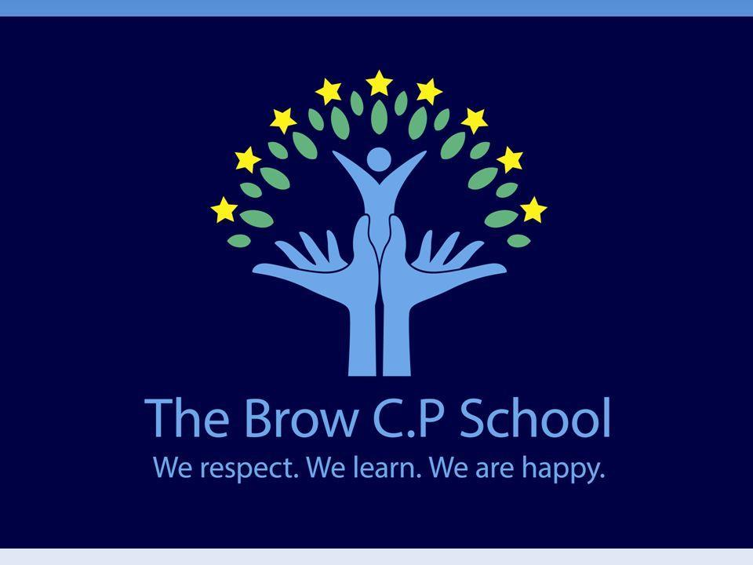

Approved by: | Lindey Webb | Date: April 2021
Information
Objectives

SINGLE EQUALITY SCHEME
The Equality Act 2010 introduced a single Public Sector Equality Duty that applies to public bodies, including maintained schools and Academies, and extends to certain protected characteristics race, disability, sex, age, religion or belief, sexual orientation, pregnancy and maternity and gender reassignment. This combined equality duty came into effect in April 2011. It has three main elements. In carrying out their functions, public bodies are required to have due regard to the need to:

· Eliminate discrimination and other conduct that is prohibited by the Act,

· Advance equality of opportunity between people who share a protected characteristic and people who do not share it,

· Foster good relations across all characteristics - between people who share a protected characteristic and people who do not share it.

Equality Objectives:
- To advance equality of opportunity by continually reviewing pupil achievement and engagement in learning and school life to ensure all pupils are included.
- To ensure that the promotion of equality and diversity is embedded in the curriculum and through our school values.

In order to meet our Equality Objectives the following activities took place over the course of the last academic year and will be continued

- All children engaged with the PHSE curriculum and daily family time activities to promote inclusion.
- Staff recognise and tackle bias and stereotyping.
- From Reception gender stereotyping is challenged. Reception staff provide resourcing to promote equality of access throughout the curriculum.
- In order to continue to develop an understanding and tolerance of difference, staff use good quality texts which address protected characteristics at an age appropriate level as core texts.
- PSHE activities promote understanding and tolerance of difference and disability. This may be in whole school assemblies and circle time.
- Listening to our pupils at all times. Using pupil voice and the pupil survey we will review the response of those in protected groups.
- Ensuring that all pupils have the opportunity to access extra-curriculum provision.

